**September 19-29, 2025, SUSTech, Shenzhen, China**

Biomedical Engineering Laboratory I (Fall 2025)

Lab 1 introduction to microscopy

|  |  |
| --- | --- |
| 涂昀烨  12313314 | Author Name  Affiliation  City, State, Country |

|  |  |  |
| --- | --- | --- |
| Author Name  Affiliation  City, State, Country | Author Name  Affiliation  City, State, Country | Author name  Affiliation  City, State, Country |

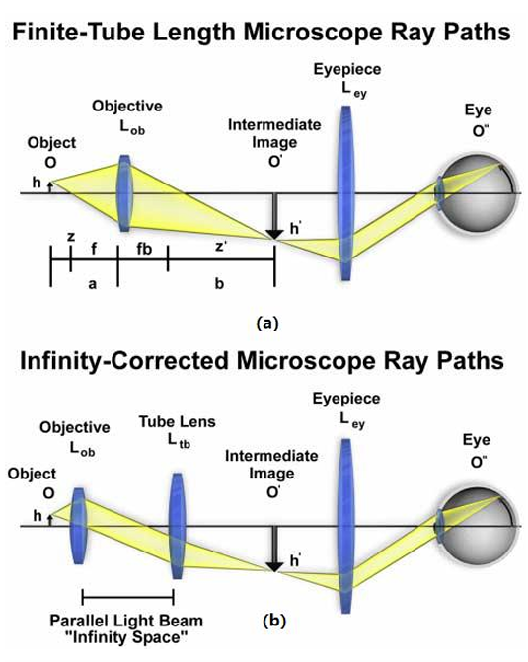

Figure 1. Schematic illustrations of (a) finite tube length and (b) infinite tube length microscopy ray paths.

Abstract

The optical microscope, a cornerstone of scientific discovery, allows human to observe the object beyond the limit of the naked eyes. Its performance is governed by the wavelength of light and the objective’s numerical aperture (NA). Here, we present four practical investigations to test the core principles and imaging techniques of optical microscope. During these experiments, we verified our microscope’s infinity-corrected design by measuring its true magnification, observed the consequent loss of resolution by altering the objective’s NA using different pinhole apertures, demonstrated the effect of phase contrast microscope against the bright-field mode, and applied fluorescence microscope to visualize the specific components within stained cells (BPAE). This lab successfully integrated theoretical optics with hands-on validation, helping us get a further understanding of modern light microscopy in biomedical research.

INTRODUCTION

The microscope is one of the greatest inventions of mankind. Before its invention, our understanding of the world was limited to what they could see with the naked eye, or with the aid of lenses. And in this lab, we mainly focus on optical microscope, which consists of eyepiece, objectives, brightness adjustment knob, coarse and fine focusing knob, stage, light bulb, phase contrast slider, etc.

Microscope resolution is the smallest distance between two distinguishable points. It is limited by the Abbe diffraction limit (d = 1.22λ / 2NA). This means resolution depends on the light's wavelength (λ) and the objective's Numerical Aperture (NA). The NA (NA = n*sinθ) measures an objective's light-gathering ability. Higher NA leads to a sharper image.

Modern optical microscopes use a two-stage magnification process, which utilizes lenses in the scope’s objective and eyepiece. One design is the finite tube length microscope (Figure 1a), while another more modern design uses infinity-corrected optics (Figure 1b).

The phase contrast microscope is designed for viewing transparent specimens. It makes invisible phase shifts in light waves visible, which involves separating the direct light from light that is diffracted and making them destructively interfere in order to form a biomedical image.

Fluorescence microscopy relies on the Stokes shift. It applies specific light on the sample, which leads to associated excitation of the fluorophore. With the emission filter, the emitted light is project as a fluorescent image to the CCD camera. The combination of images that are processed by different light shows the overall information of fluorescently areas of the sample.

In this lab, we measured the true magnification of an objective, altered its numerical aperture (NA) by using different grating. Additionally, we verified the function and role of phase contrast microscopy, and conducted fluorescence microscopy observations using Bovine Pulmonary Artery Endothelial Cells (BPAE, Figure 2).

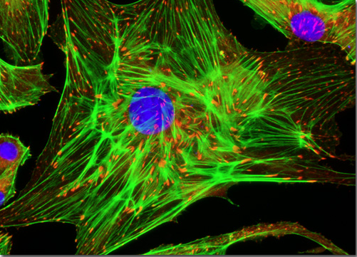

Figure 2. BPAE in fluorescence microscopy (Florida State University, 2022)

MATERIALS AND METHODS

Acknowledgments

Put acknowledgments here.

References

【1】Florida State University. (2022). Bovine pulmonary artery endothelial cells [Image]. Molecular Expressions Microscopy Primer. Retrieved October 27, 2023, from <https://micro.magnet.fsu.edu/primer/techniques/fluorescence/gallery/cells/bpae/bpaecells.html>

【2】textbook

Annex

Put Annex title here

Put text of Annex here